Jacob Dineen, Christopher Lill, Matthew Dumont, Garrett Yagade

Homework 3 Group 3

February 28th, 2017

Monday 9PM EST SCM651

**Graph the percent purchased against price**

Nonlinear data. Cannot use linear regression. Power regression to fit model.

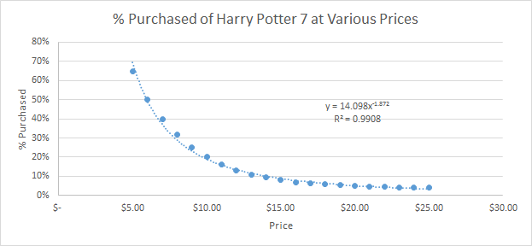

Perform a regression using power regression to determine the predicted %column.

**Graph the new curve**

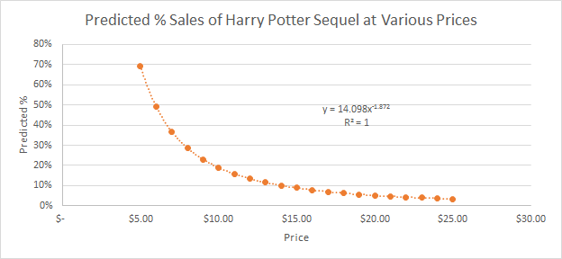

**Estimate the equation of the line**

y= 14.098x-1.872

x= selling price of an individual book.

**What does the R2 mean?**

Coefficient of Determination. R2 is the proportion of the variation in the response variable(s) that is explained by the model. In this instance, the R2 explains how well our power regression line fits with the data points; it also says how much of book sales variability is driven by our regression model.

Our R-squared for the power trendline in percent purchased of Harry Potter 7 shows that 99% of the variability in demand (dependent variable) is accounted for by the change in price (the independent variable). The R-squared of our predicted % sales shows that 100% of the variability in demand is accounted for by the change in price. An R2 value of 1 makes sense in this case because the predicted % of sales are solely based on the power equation of the previous Harry Potter book. However, if more explanatory variables were introduced, the adjusted R2 value would decline.

**Assuming there are 100,000 customers who visit your website and the publisher cost is $5.00, estimate the number of books sold (predicted sales column)**

Predicted Sales = Predicted % Purchased * 100,000 customers (see graph below)

**Calculate the revenue column (price * predicted sales)**

Revenue = Selling price of a book * Predicted Sales (see graph below)

**Calculate the profit column ((price – book cost) * predicted sales)**

Profit = Revenue - (Predicted Sales * Unit Cost) (see graph below)

**Use conditional formatting to highlight the profit values for all prices**

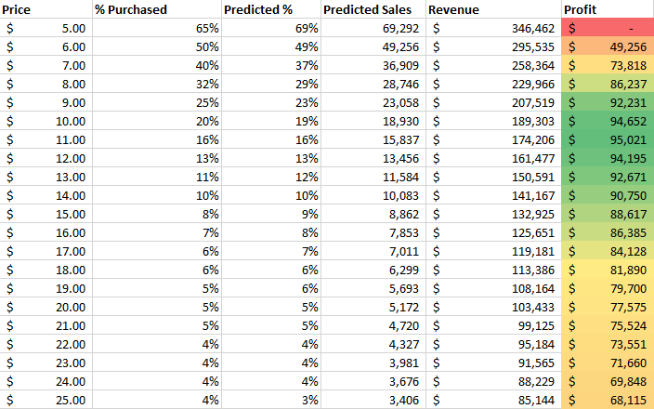

**2.**

**a.)**

i.) Measures optimal profit assuming no constraints and a unit cost of $5.00.

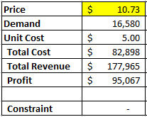

ii.) Measures optimal profit assuming demand constraint of 30,000 and a unit cost of $4.50.

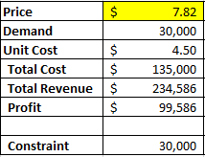

iii.) Measures optimal profit assuming demand constraint of 50,000 and a unit cost of $4.00

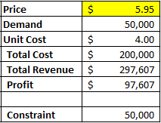

**Run a constrained optimization for each of the above situations to determine which cost point (from the publisher) and price (to your customer) maximizes your profit. Which cost point should you accept from the publisher?**

**b.)**

At a price point of $7.82 and a unit cost of $4.50, our profit is maximized at $99,587. This is dependent on the constraint of demand equaling or exceeding 30,000. It is worth noting that under the $5 cost model, our net profit percentage is 53% compared to 42% under the $4.5 cost model. Under the conditions in this assignment, would still choose the $4.5 cost model to profit maximize.

If we go back and rerun our model with each of the various unit costs, we see the following predicted profit levels:

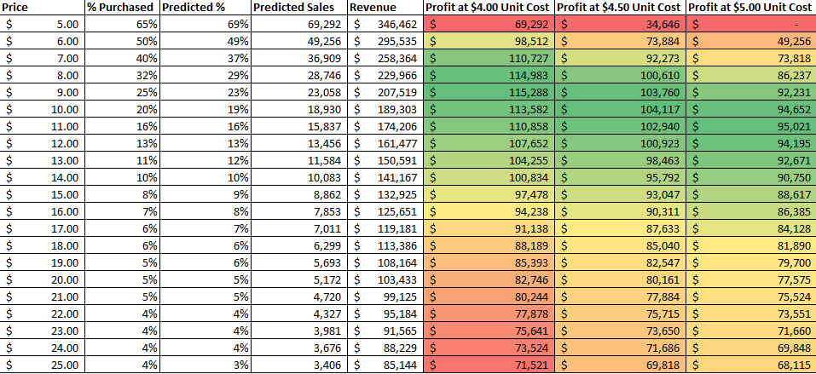

At a glance, and thinking logically, a $4.00 cost per unit production charge would amplify our profit, but then we must take our constraints into account. At a demand level of 50,000 units, we would only be able to price the product below the $6 mark, and that profit is lower than what we’d see at a $4.50 cost per unit with a lower demand constraint. At a $4.50 cost per unit, we must price our product below $7.82 to meet our demand constraint, but at the price point we would still be able to make $4,520 more than we would at a $5.00 cost point with no constraints.

It is risky to base our predicted demand on historical performance, which we’ll touch on below, but if our forecast is accurate, and we end up hitting our demand constraint, we will have manufactured an additional 5% of profit.

3.

**a.) What are the risks of using Harry Potter 7 data in predicting your new demand curve for the Harry Potter sequel?**

The most inherent risk associated with using Harry Potter 7 data is that it assumes Harry Potter 8 will be equivalently received by the fans as the prior book. Past performance is not an indicator of future behavior and by using the Harry Potter 7 data, we are relying on the book to be equally as “good”.

This is risky for two reasons, the first is if the sequel is not as well received as the prior installment the demand model for Harry Potter 8 would be inflated, we would charge too high of a price per unit and our quantity demanded may fall below 30,000. If our demand falls below 30,000 units we will be left with unsold inventory on hand which directly affects our net profits.

The second risk with accepting equivalent fan reception is that Harry Potter 8 could be widely accepted as an improvement from the previous installment. It stands to reason if Harry Potter 8 is better than we would underestimate the market demand, underprice the value of each book, and would fail to profit maximize.

Additionally, only using Harry Potter 7 data would be myopic because there is certainly data on Harry Potter 1 through 6. We are marketing Harry Potter 8 as piece of a larger franchise and to review only 1 other piece of the franchise would be a shortsighted decision.

Lastly, a third risk lies within the data. The Book Emporium collected this data, however we do not understand their collection methods or data processing steps. We are assuming data integrity when we create our demand curve and pricing model. Without detailed information on The Book Emporium’s data collection process we could execute marketing decisions based on dirty data. Furthermore, we assume The Book Emporium has correctly determined necessary sample size, has polled the appropriate demographics, and the samples properly represent the population overall. Any deviation from these measures may fail to represent the target audience, as a whole.

**b.) What other data would you like to have to perform your analysis?**

Even though R2 indicates most of the demand variability (99%) was driven by price, we cannot assume that this will remain true for Harry Potter 8, as demonstrated in part a. Other internal factors such as advertising and promotional costs may help drive demand as well. It’s important to see how this investment correlated to the success of the Harry Potter series, historically.

Also, there may be significant market changes since the release of Harry Potter 7. Perhaps there is a glut of fantasy books on the market, which creates a more competitive environment. Or tastes and preferences have changed and fantasy is generally less popular. These potential shifts in the marketplace would not be captured by previous regression models. Polling and a limited market release might shed light on these changes.

Through market research and the evaluation of previous price and cost structures, we can mitigate some of the aforementioned risks. Also, if multiple variables are in play, a multivariate regression analysis may be helpful.